|  |  |
| --- | --- |
| **WDM** | **FWDM** |
|  |  |

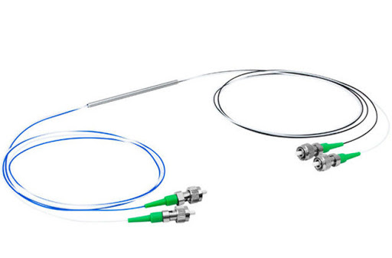

**FEATU**

**FFEATURES**

* Wide Operating Wavelength Range
* Low insertion loss
* Low Polarization Dependent Loss
* High Channel Isolation
* Specified Wavelength Available

**APPLICATIONS**

* WDM Network
* CATV Network
* Fiber Optical Amplifier
* MAN & Access Network

  **PERFORMANCE SECTION**

|  |  |  |  |  |  |  |  |
| --- | --- | --- | --- | --- | --- | --- | --- |
| **Parameter** | | **unit** |  |  | **Value** | |  |
| Pass Wavelength | | nm | 1480～1500 |  | 1540～1560 |  | 1260～1360 |
|  |  | &1480～1500 |
|  |  |  |  |  |  |  |
| Reflected Wavelength 1 | | nm | 1260～1360 |  | 1260～1360 |  | 1540～1560 |
| Reflected Wavelength 2 | | nm | 1540～1560 |  | 1480～1500 |  |
|  |  |  |
| Insertion | Pass | dB |  |  | ≤0.6 | |  |
| loss | Reflect | dB |  |  | ≤0.4 | |  |
| Isolation | Pass | dB |  |  | ＞30 | |  |
| Reflect | dB |  |  | ＞15 | |  |
|  |  |  |  |
| Polarization Dependent | | dB |  |  | ≤0.2 | |  |
| Loss | |  |  |  |
|  |  |  |  |  |  |
| Polarization Mode | | ps |  |  | ≤0.1 | |  |
| Dispersion | |  |  |  |
|  |  |  |  |  |  |
| Directivity | | dB |  |  | ≥50 | |  |
| Return Loss | | dB |  |  | ≥45 | |  |
| Operation Temperature | | ℃ |  |  | -5～+70 | |  |
| Storage Temperature | | ℃ |  |  | -40～+85 | |  |
| Package | Steel tube | mm |  |  | φ5.5x38 or specified | |  |
| dimension | ABS box | mm |  | 90x20x10 or specified | | |  |
| Connector | | - |  |  | LC/PC or specified | |  |

|  |  |  |  |  |  |  |  |  |
| --- | --- | --- | --- | --- | --- | --- | --- | --- |
| **Product** | **COMM** | **Pass** | **Reflected** | **Packa** | **Termi** | **Connec** | **Fiber** | **Fiber** |
| **Series** | **Channel** | **Channel** | **Channel** | **ge** | **nal** | **tor** | **Type** | **Length** |
|  |  |  |  |  | F=Wit |  | 0.9A=0.9 |  |
|  | 1310/149 | T14=T149 | R35=R13 | M=Ste | h | SU | 05= |
| F=FWDM | mm |
| 0/1550 | 0 | 10/1550 | el tube | conne | SA | 0.5m |
|  | G657A2 |
|  |  |  |  |  | ctor |  |  |
|  |  |  |  |  |  |  |  |
|  |  |  | R34=R13 |  | N=No | LU | 2.0A1=2.0 |  |
|  |  | T15=1550 | B=Box | conne | mm | 10= 1m |
|  |  | 10/1490 | LA |
|  |  |  |  | ctor | G657A1 |  |
|  |  |  |  |  |  |  |
|  |  | T34=T131 | R15=R15 |  |  | FU | Rb= Bare | 20= 2m |
|  |  | 0/1490 | 50 |  |  | FA | fiber |
|  |  |  |  |  |